UNIT-V
ARCHITECTURES FOR PROGRAMMABLE DSP DEVICES

- Explain the architecture of TMS320C5X with a neat block diagram.
The TMS320C5x is a fixed-point Digital Signal Processor developed by Texas Instruments. It is designed for high-speed real-time signal processing applications.
It follows a Modified Harvard Architecture allowing simultaneous access to program and data memory.

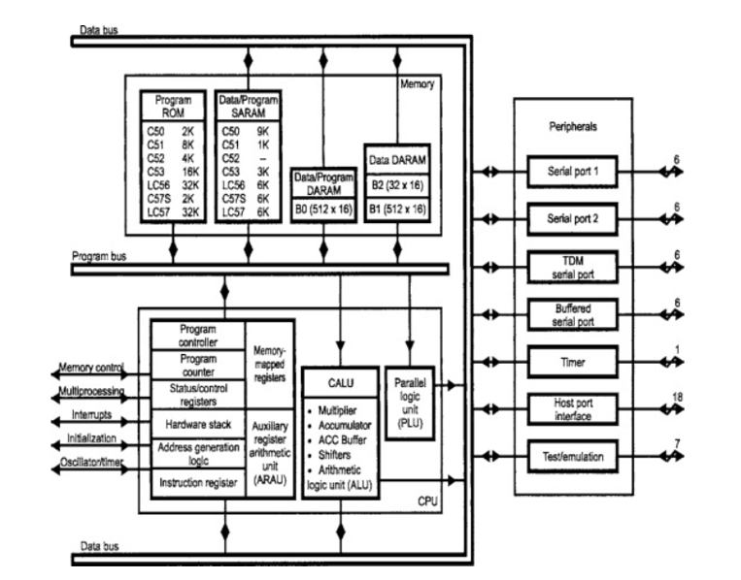
Main Components
1. CPU (Central Processing Unit)
The CPU performs all arithmetic and logical operations.
a) CALU (Central Arithmetic Logic Unit)
- Performs arithmetic operations (addition, subtraction).
- Performs logical operations (AND, OR, NOT).
- Works with a 32-bit accumulator for high precision.
b) Multiplier (MPY)
- 16 × 16 bit hardware multiplier.
- Executes multiplication in a single cycle.
- Supports MAC (Multiply–Accumulate) operation.
c) Accumulator
- 32-bit register.
- Stores intermediate results.
- Reduces overflow errors.
d) Auxiliary Registers (AR0–AR7)
- Used for indirect addressing.
- Helps in handling arrays and loops.
e) Program Controller
- Controls instruction execution.
- Contains Program Counter (PC), Instruction Register (IR), and Stack.
- Manages branching and interrupts.
f) Memory-Mapped Registers
- Used for control and status operations.
2. On-Chip Memory
a) Program Memory
- Stores instructions.
- Separate from data memory.
b) Data Memory
- Stores data samples and results.
- Enables fast data access.
c) Dual Access Capability
- Simultaneous access of program and data memory.
- Improves processing speed.
3. On-Chip Peripherals
a) Serial Port
- Used for communication with external devices.
b) Timer
- Provides timing and synchronization.
c) Interrupt Controller
- Handles internal and external interrupts.
d) I/O Ports
- Interface with external hardware.
2 (a)List the basic architectural features of programmable DSPs.

Programmable Digital Signal Processors (DSPs) such as those developed by Texas Instruments are specially designed to perform high-speed numerical operations required in signal processing applications.
Features of TMS320C5x
1. Modified Harvard Architecture
- Separate program memory and data memory.
- Allows simultaneous instruction and data access.
2. High-Speed Arithmetic Unit
- Contains 16 × 16 multiplier.
- Supports single-cycle multiply–accumulate (MAC) operation.
3. 32-bit Accumulator
- Stores intermediate results.
- Improves precision in calculations.
4. Multiple Addressing Modes
Supports several addressing modes such as:
- Immediate addressing
- Direct addressing
- Indirect addressing
- Indexed addressing
5. Auxiliary Registers
- Contains 8 auxiliary registers (AR0–AR7).
- Used for address generation and data manipulation.
6. Parallel Processing
- Arithmetic operations and logic operations can occur simultaneously.
7. On-Chip Memory
Includes internal memory for:
- Program storage
- Data storage
8. On-Chip Peripherals
The processor includes built-in peripherals such as:
- Serial ports
- Timers
- Interrupt controller
9. Low Power Consumption
Designed for efficient power usage in embedded systems.
(b) Explain the bus architecture of programmable DSPs.

The bus architecture of programmable DSPs (such as those from Texas Instruments) is designed to support high-speed data transfer using multiple buses.
Definition
A bus is a group of lines used to transfer data, instructions, and addresses between CPU, memory, and peripherals.

Types of Buses
1. Program Bus
- Transfers instructions from program memory to CPU
- Used during instruction fetch

2. Data Bus
- Transfers data between CPU and data memory
- Supports read and write operations
3. Address Bus
- Carries address information
- Selects memory locations for data/instructions
Key Feature
- DSPs use separate program and data buses
- Based on Harvard architecture
- Allows simultaneous instruction fetch and data access
Advantages
- Faster execution
- Parallel processing
- Efficient real-time performance

3. Describe the bus structure of TMS320C5X. Explain how separate program and data buses help in DSP performance.
Bus Structure of TMS320C5x and Its Impact on DSP Performance
The TMS320C5x DSP processor developed by Texas Instruments uses a multi-bus architecture based on the Modified Harvard Architecture to achieve high-speed data transfer and efficient processing.
1. Bus Structure of TMS320C5x
A bus is a group of lines used to transfer data, instructions, and addresses between CPU, memory and peripherals.
The TMS320C5x has three main buses:
1. Program Bus
- Transfers instructions from program memory to CPU
- Unidirectional (memory → CPU)
- Used for instruction fetch
2. Data Bus
- Transfers data between CPU and data memory
- Bidirectional (read/write operations)
3. Address Bus
- Carries address information
- Used to select memory locations
- Common for both program and data memory
Neat Diagram (Bus Organization)
Program Memory
|
----------------
| Program Bus |
----------------
|
CPU
|
----------------
| Data Bus |
----------------
|
Data Memory
(Address bus connects CPU to both memories)
2. Separate Program and Data Buses
- Program memory and data memory are physically separate
- Each has its own bus:
  - Program Bus → Instructions
  - Data Bus → Data
This is called Modified Harvard Architecture
3. How Separate Buses Improve DSP Performance
1. Simultaneous Access
- CPU can:
  - Fetch instruction
  - Access data
at the same time
Reduces execution time
2. Increased Processing Speed
- No waiting between instruction fetch and data transfer
Improves overall speed

3. Efficient MAC Operation
- Multiply-Accumulate requires:
  - Instruction
  - Data simultaneously
Achieved in single clock cycle
4. Supports Pipelining
- While one instruction executes, next is fetched
Improves throughput
5. Reduced Memory Bottleneck
- Separate buses eliminate conflict between instruction and data access
Advantages of Bus Structure
- High-speed operation
- Parallel data transfer
- Efficient real-time processing
- Better CPU utilization

4. What is the Central Arithmetic Logic Unit (CALU) in TMS320C5X? What are its functions and how does it support DSP operations?
The Central Arithmetic Logic Unit (CALU) is the main computational unit of the TMS320C5x DSP processor developed by Texas Instruments. It is responsible for performing all arithmetic, logical, and shift operations required in digital signal processing.
Block Diagram of CALU
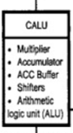
Main Components of CALU
1. Multiplier
- 16 × 16 bit hardware multiplier
- Performs fast multiplication
- Output sent to accumulator
2. Accumulator (32-bit)
- Stores intermediate and final results
- Includes guard bits to prevent overflow
- Improves precision
3. ACC Buffer
- Temporary storage register
- Holds multiplier output before accumulation
4. Arithmetic Logic Unit (ALU)
- Performs:
  - Addition
  - Subtraction
  - Logical operations (AND, OR, XOR)
5. Shifter
- Performs left and right shift operations
- Used for scaling and normalization
Functions of CALU
1. Arithmetic Operations
- Addition, subtraction, multiplication
- High-speed execution
2. Logical Operations
- AND, OR, XOR, NOT
- Used in decision-making
3. Multiply-Accumulate (MAC) Operation
$$y(n)=y(n)+x(n)⋅h(n)$$
- Performed in single clock cycle
- Most important DSP operation
4. Shift Operations
- Left shift → multiplication
- Right shift → division
- Used for scaling
5. Data Scaling and Normalization
- Maintains data within range
- Prevents overflo
How CALU Supports DSP Operations
1. High-Speed Computation
- Executes operations in single cycle
- Suitable for real-time applications
2. Efficient MAC Execution
- Widely used in:
  - Digital filters
  - Convolution
  - FFT
3. Parallel Processing
- Works simultaneously with:
  - Memory
  - Program control unit
- Improves overall speed
4. High Precision
- 32-bit accumulator reduces round-off errors
5. Continuous Computation
- Stores intermediate results internally
- Reduces memory access
5. (a)Explain Arithmetic and logic unit.
The Arithmetic and Logic Unit (ALU) is an important part of the CPU in DSP processors like those from Texas Instruments. It performs all arithmetic and logical operations on data.
Definition
ALU is a digital circuit that performs mathematical and logical operations on input data.

Functions of ALU
1. Arithmetic Operations
- Addition
- Subtraction
- Multiplication
- Division (in some processors)
2. Logical Operations
- AND
- OR
- NOT
- XOR
3. Comparison Operations
- Greater than
- Less than
- Equal to
4. Shift Operations
- Left shift (multiplication)
- Right shift (division)
Role in DSP
- Performs high-speed computations
- Supports operations like MAC (Multiply-Accumulate)
- Essential for signal processing applications

(b)Summarize the organization of on-chip memory of programmable DSPs.

The on-chip memory in programmable DSPs like those from Texas Instruments is organized to provide fast and parallel access for instructions and data.

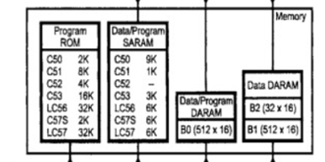
1. Program Memory (ROM)
- Stores program instructions
- Typically ROM/EPROM
- Size varies (2K, 8K, 16K, 32K words depending on processor)
- Accessed through program bus

2. Data/Program SARAM (Single Access RAM)
- Can be used for both program and data storage
- Flexible memory usage
- Single access per cycle

3. Data/Program DARAM (Dual Access RAM)
- Example: B0 (512 × 16)
- Allows two accesses in one cycle
- Can be used for both program and data
Improves processing speed

4. Data DARAM
- Example: B1, B2 (512 × 16 each)
- Used mainly for data storage
- Supports simultaneous data operations

5. Separate Memory Organization
- Program memory and data memory are logically separated
- Based on Harvard architecture
Enables:
- Simultaneous instruction fetch
- Data access

Advantages
- High-speed memory access
- Parallel processing capability
- Efficient execution of DSP algorithms
- Reduced memory access delay

6. Explain the role of Auxiliary Register ALU (ARAU), index registers and block-move address registers in TMS320C5X addressing and data movement.
The TMS320C5x DSP processor developed by Texas Instruments uses specialized units like ARAU, index registers, and block move address registers to perform efficient addressing and fast data movement, which are essential in DSP operations.
1. Auxiliary Register ALU (ARAU)
Definition
The Auxiliary Register Arithmetic Logic Unit (ARAU) is a dedicated unit used for address calculations.
Functions
- Performs arithmetic operations on auxiliary registers (AR0–AR7)
- Generates effective addresses for memory access
- Supports:
  - Increment / Decrement
  - Addition / Subtraction
  - Circular addressing
Role in DSP
- Enables fast address generation without using main ALU
- Supports indirect addressing modes
- Improves overall execution speed

2. Auxiliary Registers (AR0–AR7 / Index Registers)
Definition
- Set of 8 registers (AR0 to AR7) used as index registers
- Store memory addresses
Functions
- Used for indirect addressing
- Hold pointers to data in memory
- Support operations like:
  - Auto-increment (AR+)
  - Auto-decrement (AR-)
Role in DSP
- Efficient access to arrays and buffers
- Used in loops and repetitive operations
- Essential for DSP algorithms like filtering and FFT
3. Block Move Address Registers
Definition
- Special registers used during block data transfer operations
Functions
- Store:
  - Source address
  - Destination address
  - Block size
- Automatically update addresses during transfer
Role in DSP
- Enables fast transfer of large data blocks
- Reduces CPU involvement
- Improves efficiency in:
  - Data copying
  - Buffer management
Overall Role in Addressing and Data Movement
1. Efficient Address Generation
- ARAU calculates addresses quickly
- Auxiliary registers store address pointers
2. Fast Data Access
- Index registers enable quick memory access
- Reduces instruction execution time
3. High-Speed Data Transfer
- Block move registers allow bulk data movement
- Minimizes overhead
4. Support for DSP Algorithms
- Useful in:
  - Circular buffers
  - Filtering
  - FFT operations

Advantages
- Faster execution
- Reduced CPU load
- Efficient memory utilization
- Supports real-time processing
7. Identify the addressing modes of the operands in each of the following instructions
i. ADD #1234h
ii. ADD 1234h
iii. ADD *AR+
iv. ADD offsetreg-,*AR
Addressing Modes in Given Instructions
Addressing modes specify how the operand (data) is accessed in an instruction. In TMS320C5x DSP processors from Texas Instruments, multiple addressing modes are supported for efficient data access.
i. ADD #1234h
Addressing Mode: Immediate Addressing
Explanation:
- The symbol # indicates immediate data
- The operand 1234h is a constant given directly in the instruction
- No memory access is required
Operation:
- Add the constant value 1234h to the accumulator
ii. ADD 1234h
Addressing Mode: Direct Addressing
Explanation:
- The operand 1234h represents a memory address
- The data stored at that memory location is accessed
Operation:
- Fetch data from memory location 1234h
- Add it to the accumulator
iii. ADD AR+
Addressing Mode: Indirect Addressing with Auto-Increment
Explanation:
- *AR means indirect addressing using auxiliary register (AR)
- The register contains the address of the operand
- + means increment the register after access
Operation:
- Access data from memory location pointed by AR
- Add it to accumulator
- Increment AR automatically
iv. ADD offsetreg-, AR
Addressing Mode: Indexed Addressing with Auto-Decrement and Indirect Addressing
Explanation:
- offsetreg-:
  - Uses an index register (offset register)
  - Address is modified using offset
  - - indicates auto-decrement
- AR:
  - Indicates indirect addressing
Operation:
- Effective address is calculated using offset register
- Data is accessed indirectly through AR
- Offset register is decremented after operation
Summary Table
Instruction | Addressing Mode
ADD #1234h | Immediate Addressing
ADD 1234h | Direct Addressing
ADD *AR+ | Indirect Addressing with Auto-Increment
ADD offsetreg-, *AR | Indexed Addressing with Auto-Decrement + Indirect Addressing

8. Explain Harvard and Von Nenumann architectures.

Computer architecture defines the organization of CPU, memory and buses. The two important architectures are Von Neumann Architecture and Harvard Architecture.

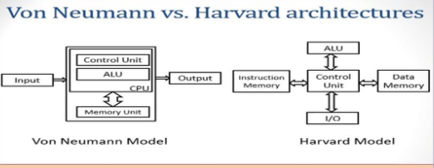

1. Von Neumann Architecture
Definition
The Von Neumann Architecture is a computer architecture in which both program instructions and data are stored in the same memory and share a single bus for communication.
Working
- CPU fetches instruction and data one at a time
- Uses the same bus for both operations

Features
- Single memory unit
- Single bus system
- Sequential execution

Advantages
- Simple design
- Low cost
- Easy implementation

Disadvantages
- Von Neumann bottleneck (only one transfer at a time)
- Slower execution
- No parallel processing

2.Harvard Architecture

Definition
The Harvard Architecture uses separate memories for program instructions and data, each with its own separate bus.
Working
- CPU can fetch instruction and data simultaneously
- Uses separate buses

Features
- Separate memory units
- Separate buses
- Parallel processing

Advantages
- Faster execution
- No memory conflict
- Efficient for DSP operations

Disadvantages
- Complex design
- Higher cost
Comparison Between Architectures
Feature | Von Neumann | Harvard
Memory | Single | Separate
Bus | Single | Separate
Speed | Slow | Fast
Parallelism | Not possible | Possible
Complexity | Simple | Complex

9. What is the Parallel Logic Unit (PLU) in TMS320C5X? What operations is it used for and why is it useful?

The Parallel Logic Unit (PLU) is a special functional unit in the TMS320C5x DSP processor developed by Texas Instruments. It is used to perform logical operations in parallel with arithmetic operations of the CPU.
Definition
The PLU is a hardware unit that performs bit-level logical operations simultaneously with the main CPU operations, thereby improving overall processing efficiency.
Functions of PLU
1. Logical Operations
The PLU performs basic logical operations such as:
- AND
- OR
- XOR
- NOT
2. Bit Manipulation
- Used for setting, clearing, and testing bits
- Useful in control and status operations
3. Masking Operations
- Applies masks to data
- Extracts or modifies specific bits
4. Compare Operations
- Helps in checking bit patterns
- Used in decision-making processes
Parallel Operation of PLU
- PLU operates in parallel with CALU (Central Arithmetic Logic Unit)
- While CALU performs arithmetic operations, PLU performs logical operations simultaneously
This reduces total execution time
Why PLU is Useful
1. Increased Speed
- Executes logical operations without interrupting arithmetic operations
- Improves overall throughput
2. Efficient Bit Processing
- DSP applications often require bit-level manipulation
- PLU handles these efficiently
3. Reduced CPU Load
- Offloads logical tasks from main ALU
- Allows CPU to focus on arithmetic operations
4. Supports Real-Time Processing
- Faster execution makes it suitable for real-time DSP applications
Applications of PLU
- Signal processing algorithms
- Data masking and encoding
- Control operations
- Status checking
10. Explain some important flags in the status registers of TMS320C5X and their role during DSP operations.
Important Flags in Status Registers of TMS320C5x and Their Role
The TMS320C5x DSP processor, developed by Texas Instruments, contains status registers that hold important flag bits. These flags indicate the result of operations and control the execution of DSP programs.
Status Registers in TMS320C5x
- Main status registers include:
  - ST0 (Status Register 0)
  - ST1 (Status Register 1)
These registers contain several flags (bits) that reflect processor conditions.
Important Flags and Their Functions
1. Carry Flag (C)
- Indicates carry or borrow in arithmetic operations
- Set when:
  - Addition produces carry
  - Subtraction requires borrow
Role:
Used in multi-word arithmetic operations
2. Zero Flag (Z)
- Set when the result of an operation is zero
Role:
Used for:
- Conditional branching
- Loop control
3. Negative Flag (N)
- Set when the result is negative (MSB = 1)
Role:
Indicates sign of result in signed operations
4. Overflow Flag (V)
- Set when arithmetic overflow occurs
Role:
Prevents incorrect results in DSP computations
5. Overflow Mode Flag (OVM)
- Controls overflow handling:
  - Wrap-around
  - Saturation
Role:
Important in DSP to avoid distortion

6. Sign Extension Mode Flag (SXM)
- Controls sign extension of data
Role:
Ensures correct handling of signed numbers
7. Test/Control Flags (TC, etc.)
- Used for testing conditions
- Supports decision-making instructions
8. Interrupt Mask Flag (INTM)
- Enables or disables interrupts
Role:
Controls interrupt handling in real-time systems
Role of Flags in DSP Operations
1. Decision Making
- Used in conditional instructions
- Example: branch if zero
2. Error Detection
- Overflow and carry flags detect errors
3. Loop Control
- Zero flag helps in loop termination
4. Data Integrity
- Flags ensure correct arithmetic results
5. Real-Time Processing
- Interrupt flags help in handling external events
Advantages
- Improves program control
- Enables efficient branching
- Ensures accuracy in computations
- Supports real-time DSP applications

